DSA0502 – Query Processing for Data Science
Course Faculty | Dr. B .SHYAMALA GOWRI
Reg. No. | 192424050
Student Name | THARUN V

LAB PROGRAMS 5 AND 6
5. Write a Pandas program to create a bar plot of the trading volume of Alphabet Inc. stock between two specific dates.
Aim:
To create a bar plot of the trading volume of Alphabet Inc. between two specific dates.
Dataset:
%%writefile Alphabet.csv
Date,Open,High,Low,Close,Volume
2020-01-02,68.72,69.20,68.20,68.90,28132000
2020-01-06,69.10,70.00,68.80,69.80,29000000
2020-01-10,70.20,71.10,69.90,70.80,30000000
2020-01-15,71.20,72.10,70.90,71.80,29500000
2020-01-20,72.00,72.80,71.50,72.40,31000000
2020-01-24,72.50,73.10,72.00,72.90,30500000
2020-01-30,73.20,74.00,72.90,73.80,31500000
2020-02-03,74.50,75.20,73.80,74.90,32000000
2020-02-18,75.80,76.50,75.00,76.10,31500000
2020-03-02,67.50,68.30,66.80,67.90,42000000
2020-03-16,55.20,56.10,54.00,55.80,62000000
2020-03-31,58.60,59.20,57.80,58.90,51000000
2020-04-15,61.30,62.50,60.80,62.00,39000000
2020-04-30,66.10,67.00,65.50,66.70,36000000
2020-05-15,69.80,70.40,69.10,70.00,33000000
2020-05-29,70.90,71.60,70.10,71.30,34000000
2020-06-15,72.40,73.00,71.90,72.80,31000000
2020-06-30,70.80,71.50,70.20,71.10,29500000
Code:
import pandas as pd
import matplotlib.pyplot as plt
df = pd.read_csv("Alphabet.csv")
df["Date"] = pd.to_datetime(df["Date"])
data = df[(df["Date"] >= "2020-01-01") & (df["Date"] <= "2020-01-31")]
plt.figure(figsize=(10,5))
plt.bar(data["Date"].dt.strftime("%Y-%m-%d"), data["Volume"])
# Display volume values on top of each bar
for i, value in enumerate(data["Volume"]):
plt.text(i, value + 200000, f'{value:,}', ha='center', fontsize=8)
plt.xlabel("Date")
plt.ylabel("Trading Volume")
plt.title("Alphabet Inc. Trading Volume (Jan 2020)")
plt.xticks(rotation=45)
plt.tight_layout()
plt.show()Output:
Bar chart showing trading volume.
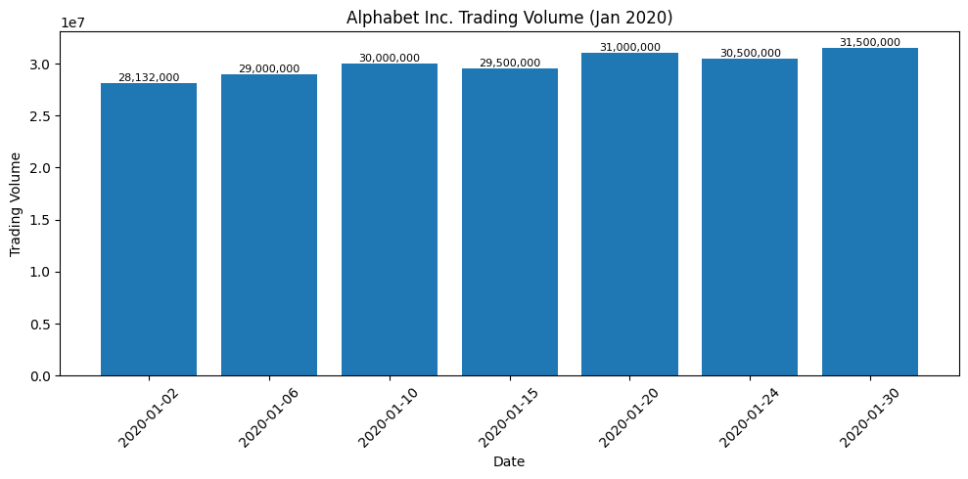
Result:
Thus, the trading volume bar chart was generated successfully.

6. Write a Pandas program to create a scatter plot of the trading volume and stock prices of Alphabet Inc. stock between two specific dates.
Aim:
To create a scatter plot of the trading volume and stock prices of Alphabet Inc.
Dataset:
%%writefile Alphabet.csv
Date,Open,High,Low,Close,Volume
2020-01-02,68.72,69.20,68.20,68.90,28132000
2020-01-06,69.10,70.00,68.80,69.80,29000000
2020-01-10,70.20,71.10,69.90,70.80,30000000
2020-01-15,71.20,72.10,70.90,71.80,29500000
2020-01-20,72.00,72.80,71.50,72.40,31000000
2020-01-24,72.50,73.10,72.00,72.90,30500000
2020-01-30,73.20,74.00,72.90,73.80,31500000
2020-02-03,74.50,75.20,73.80,74.90,32000000
2020-02-18,75.80,76.50,75.00,76.10,31500000
2020-03-02,67.50,68.30,66.80,67.90,42000000
2020-03-16,55.20,56.10,54.00,55.80,62000000
2020-03-31,58.60,59.20,57.80,58.90,51000000
2020-04-15,61.30,62.50,60.80,62.00,39000000
2020-04-30,66.10,67.00,65.50,66.70,36000000
2020-05-15,69.80,70.40,69.10,70.00,33000000
2020-05-29,70.90,71.60,70.10,71.30,34000000
2020-06-15,72.40,73.00,71.90,72.80,31000000
2020-06-30,70.80,71.50,70.20,71.10,29500000
Code:
import pandas as pd
import matplotlib.pyplot as plt
df = pd.read_csv("Alphabet.csv")
plt.scatter(df["Volume"],df["Close"])
plt.show()
Output:
Scatter plot showing Volume vs Close Price.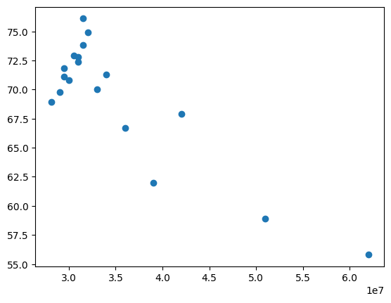
Result:
Thus, the scatter plot was generated successfully.

